Experiment No 7
Roll No:24141030 Lab: PL-II

Theory:
1. Introduction to Functions
A function is a reusable block of code that performs a specific task. Functions help in modular programming, code reusability, better organization, and easier debugging. Python provides built-in functions (like print(), len()) and allows users to define their own functions.

2. Advantages of Functions
Advantage | Description
Reusability | Write once, use multiple times
Modularity | Break complex problems into smaller parts
Abstraction | Hide implementation details
Maintainability | Easier to debug and update
Testing | Can test individual functions

3. Function Syntax
def function_name(parameters):
return value

4. Components of a Function
Component | Description
def | Keyword to define a function
function_name | Identifier for the function
parameters | Input values (optional)
docstring | Documentation string (optional)
body | Code to execute
return | Statement to return value (optional)

5. Types of Arguments
Type | Description | Example
Positional | Passed in correct order | func(a, b)
Keyword | Passed with parameter name | func(b=2, a=1)
Default | Has default value if not provided | def func(a=5)
Variable-length (*args) | Accepts any number of positional args | def func(*args)
Variable-length (kwargs)** | Accepts any number of keyword args | def func(**kwargs)

6. Return Statement
The return statement exits a function and optionally returns a value.
Feature | Description
No return | Returns None
Single return | Returns one value
Multiple returns | Returns tuple of values
Early return | Exit function before end

7. Scope of Variables
Scope | Description
Local | Variables defined inside a function; accessible only within that function
Global | Variables defined outside any function; accessible throughout the module
Enclosing | Variables in outer functions (nested functions)
Built-in | Python's built-in names

8. Global Keyword
The global keyword allows a function to modify a global variable.

10. Lambda Functions
Lambda functions are small, anonymous functions defined using the lambda keyword.
Syntax: lambda parameters: expression
Characteristics:
- Can have any number of parameters but only one expression
- Cannot contain statements or multiple expressions
- Automatically returns the expression result
- Often used with map(), filter(), sorted()

Programs and Code:
1. Program to define and call a function
def greet():
print("Hello! Welcome to Python functions.")
print("This is a simple function demonstration.")
print("Calling the function:")
greet()
print("\nFunction called successfully!")
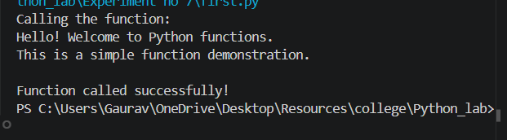
2. Program to pass arguments to a function
def add_numbers(a, b):
result = a + b
print(f"Sum of {a} and {b} is {result}")
return result
x = int(input("Enter first number: "))
y = int(input("Enter second number: "))
result = add_numbers(x, y)
print(f"Returned value: {result}")
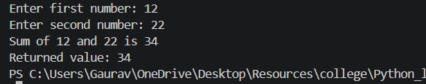
3. Program to return multiple values from a function
def calculate(a, b):
return a + b, a - b, a * b, a / b
x = 10
y = 3
print(f"Numbers: {x}, {y}")
s, d, p, q = calculate(x, y)
print(f"Sum: {s}")
print(f"Difference: {d}")
print(f"Product: {p}")
print(f"Quotient: {q:.2f}")
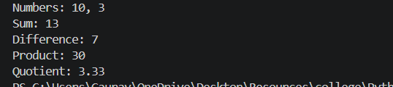
4. Program to calculate factorial using function
def factorial(n):
"""Calculate factorial iteratively"""
if n < 0:
return "Undefined (negative number)"
fact = 1
for i in range(1, n + 1):
fact *= i
return fact
num = int(input("Enter a number: "))
result = factorial(num)
print(f"Factorial of {num} is {result}")
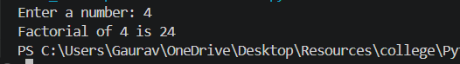
5. Program to calculate factorial using recursion
def factorial_recursive(n):
# Base case
if n <= 1:
return 1
return n * factorial_recursive(n - 1)
num = int(input("Enter a number: "))
if num < 0:
print("Factorial is not defined for negative numbers")
else:
result = factorial_recursive(num)
print(f"Factorial of {num} (recursive) is {result}")
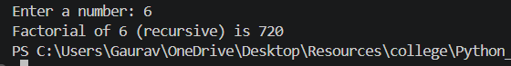
6. Program to generate Fibonacci series using recursion
def fibonacci(n):
# Base cases
if n <= 0:
return 0
elif n == 1:
return 1
return fibonacci(n - 1) + fibonacci(n - 2)
terms = int(input("Enter number of terms: "))
print("Fibonacci series:")
for i in range(terms):
print(fibonacci(i), end=" ")
print()
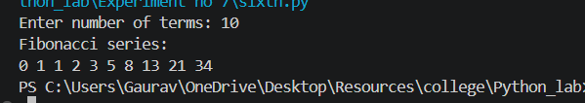
7. Program to demonstrate lambda function
print("=== Lambda Function Demonstrations ===")
square = lambda x: x ** 2
print(f"Square of 5: {square(5)}")
add = lambda a, b: a + b
print(f"Sum of 10 and 20: {add(10, 20)}")
# Lambda with filter (get even numbers)
numbers = [1, 2, 3, 4, 5, 6, 7, 8, 9, 10]
evens = list(filter(lambda x: x % 2 == 0, numbers))
print(f"Even numbers: {evens}")
# Lambda with map (square all numbers)
squares = list(map(lambda x: x ** 2, numbers))
print(f"Squares: {squares}")
# Lambda with sorted (sort by second element)
pairs = [(1, 'one'), (3, 'three'), (2, 'two')]
sorted_pairs = sorted(pairs, key=lambda x: x[1])
print(f"Sorted by word: {sorted_pairs}")
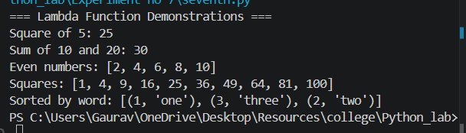
8. Program to use built-in functions
numbers = [5, 2, 8, 1, 9, 3, 7, 4, 6]
print(f"List: {numbers}")
print(f"Length: {len(numbers)}")
print(f"Maximum: {max(numbers)}")
print(f"Minimum: {min(numbers)}")
print(f"Sum: {sum(numbers)}")
print(f"Sorted ascending: {sorted(numbers)}")
print(f"Sorted descending: {sorted(numbers, reverse=True)}")
print(f"Absolute of -10: {abs(-10)}")
print(f"Power 2^5: {pow(2, 5)}")
print(f"Round 3.14159 to 2 decimals: {round(3.14159, 2)}")
print(f"Type of 10: {type(10)}")
print(f"Type of 'Hello': {type('Hello')}")
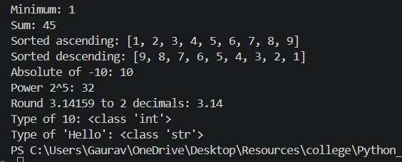
9. Program to demonstrate scope of variables
global_var = "I am global"
def demo_scope():
# Local variable
local_var = "I am local"
print("\nInside function:")
print(f" Accessing global_var: {global_var}")
print(f" Accessing local_var: {local_var}")
global global_var
global_var = "Modified global"
print(f" Modified global_var inside function: {global_var}")
print("Outside function (before call):")
print(f" {global_var}")
demo_scope()
print("\nOutside function (after call):")
print(f" {global_var}")
# print(local_var) # This will cause error - local_var not accessible
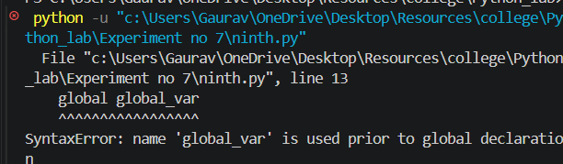
10. Program to check prime number using function
def is_prime(n):
if n <= 1:
return False
if n == 2:
return True
if n % 2 == 0:
return False
for i in range(3, int(n ** 0.5) + 1, 2):
if n % i == 0:
return False
return True
num = int(input("Enter a number: "))
if is_prime(num):
print(f"{num} is a Prime number")
else:
print(f"{num} is not a Prime number")
print("\nPrime numbers between 1 and 50:")
for i in range(1, 51):
if is_prime(i):
print(i, end=" ")
print()
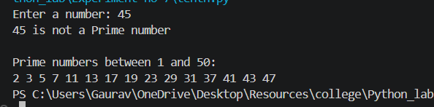

Conclusion: In this experiment, we studied functions and recursion in Python including function definition/calling, passing arguments, returning multiple values, factorial (iterative and recursive), Fibonacci recursion, lambda functions, built-in functions, variable scope, and prime checking functions. Functions enable modular, reusable, and well-organized code, while recursion provides elegant solutions for problems with recursive nature.

